Forwards, Futures, Swaps & Options

Forwards, futures, swaps & options are derivative instruments, that is, their value is derived from the price performance of an underlying asset.
Forwards, futures and swaps are terminal instruments, meaning that there has to be a closing transaction to the contract (it is a legal obligation). With options, the holder has the choice of whether they want to complete the transaction.
With forwards & futures you are locking yourself into a fixed price at some point in the future, either you agree to buy at that price, or you agree to sell at that price.
With options you are protecting yourself against an adverse move, but if there is a favourable move in the underlying, you can take advantage of that and simply let the option lapse.
Forwards, futures and swaps would be used by hedgers (who could be large companies), who want to remove uncertainty from their future cash flows. This will make the company less risky and please debt holders. Shareholders will be pleased when it works in their favour, but be less pleased when the company would have been better off without the hedge.
If the company hedges and rivals don’t and the underlying asset moves favourably (if you were unhedged), then the rivals have a competitive advantage and may be able to exert pricing pressure against the hedged company.

Payoffs to Forwards, Futures & Options
Forwards and futures are very similar in nature, so the payoff diagrams are the same.
Imagine a situation where you have a user of aluminium, say a car manufacturer, and the producer of aluminium, a large steel company. The aluminium price has been volatile over the past few years. The car manufacturer would like to buy when the price is low and the aluminium producer would like to sell when prices are high. But the car manufacturer cannot buy and stockpile years of aluminium. They both have to take the prices that are in the market.
The car manufacturer is worried about having to pay higher and higher prices for the aluminium. This will eat into the profits it makes on selling its cars. The price of aluminium is $2000 on the markets just now. How can the car manufacturer remove some risk from its operation?
The car company’s exposure to aluminium price changes is shown below;
As the price of aluminium rises from $2000, the car producer has to pay higher and higher prices for its supply. This will impact its profitability and its cash flow. It may even affect its ability to service its debt.
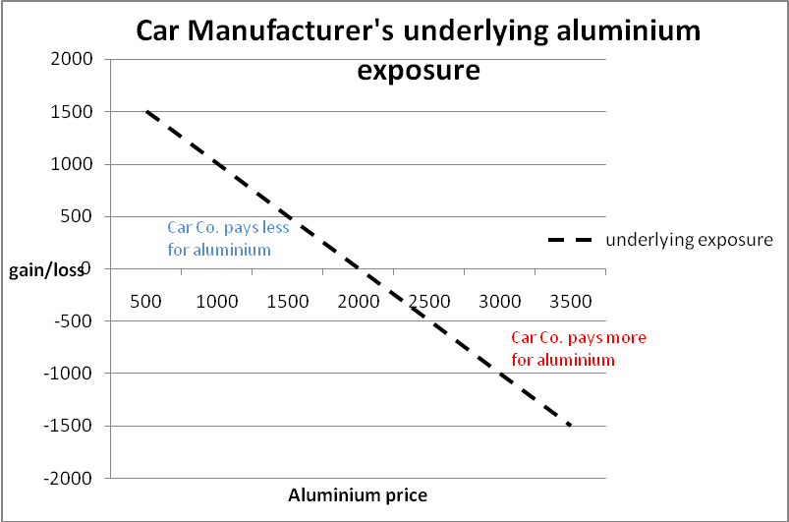

The car company would like to remove this risk from its operations. To do this they could buy futures contracts on aluminium. Say the three month futures price for aluminium is $2000 per tonne. This would mean they have the obligation to buy aluminium at $2000 in three months time, if they buy the futures contract.
This will lock them in at $2000. If the price of aluminium goes up to $3000, then they will have to pay $3000 per tonne in the market place, but they could then sell their futures contract for $3000. They will have lost $1000 relative to the aluminium price today on the underlying aluminium, but they will have made $1000 on the futures contract, which they have just closed by selling it. They have a fixed price of $2000.
If the aluminium price fell, they are locked in at $2000, they would be able to buy aluminium cheaper in the market place, but they would suffer a loss on selling the futures contract (when they close the position, as they have to).
The payoff diagram for the futures purchase is shown below;
The diagram shows that as the aluminium price rises, the futures contract (Buy futures) will rise in value, offsetting the relative loss on the underlying aluminium, fixing a price of $2000.

Buy futures contract payoff
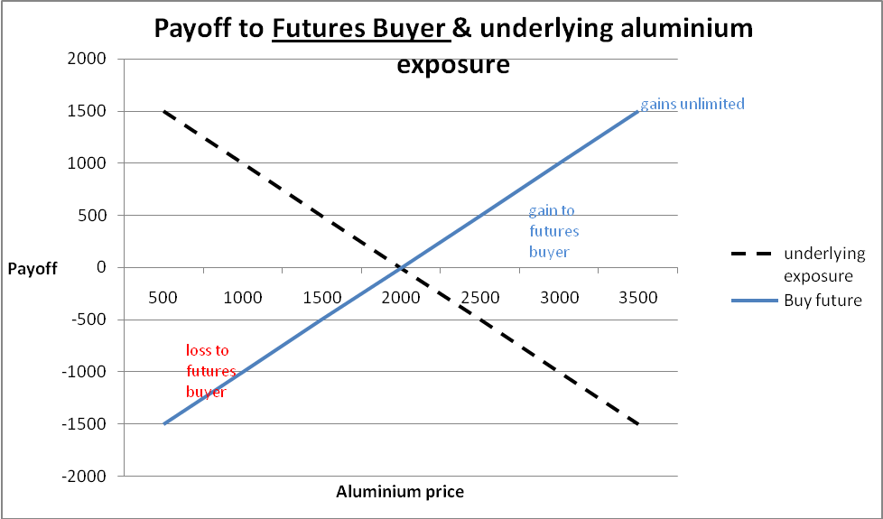
The table below show the payoffs to different prices. The future is bought at $2000. If the aluminium price rises to $3000, the company can sell the future for $3000, making a profit of $1000, but they have to pay $3000 for the aluminium in the cash market, which is $1000 more than the price today. Netting these out you are left with a price of $2000 (gain of $1000 and a loss of £1000 on the original $2000 price).
Aluminium Futures Buyer |  |  | aluminium price = | 2000
Commodity buyer |  | aluminium spot | underlying
eg. Car manufacturer |  | price | exposure | Buy future
 |  | 500 | 1500 | -1500
 |  | 1000 | 1000 | -1000
 |  | 1500 | 500 | -500
 |  | 2000 | 0 | 0
 |  | 2500 | -500 | 500
 |  | 3000 | -1000 | 1000
 |  | 3500 | -1500 | 1500

Position of aluminium producer
The aluminium producer has the opposite exposure to the car manufacturer. The producer would like to see higher prices; this is good for their business. What they are worried about is if the aluminium price falls. If it falls they may end up in the position of failing to generate enough cash flow to service their obligations.
The aluminium producer would sell the futures contract. If the price of aluminium had fallen by the time they have to sell the product, then the future could be closed out (bought back) for less than it was sold for. The producer would make a profit on the futures contract, but a relative loss on the cash aluminium sale. For example, if the price of aluminium was $2000 and the producer sold a three month futures contract for $2000 and the price in three months was $1500, then they could buy the future at $1500. They would make a profit of $500 on the future, but lose $500 on the cash aluminium sale. There net price would be $2000.
The payoff diagram is below;
Payoff to Future contract seller
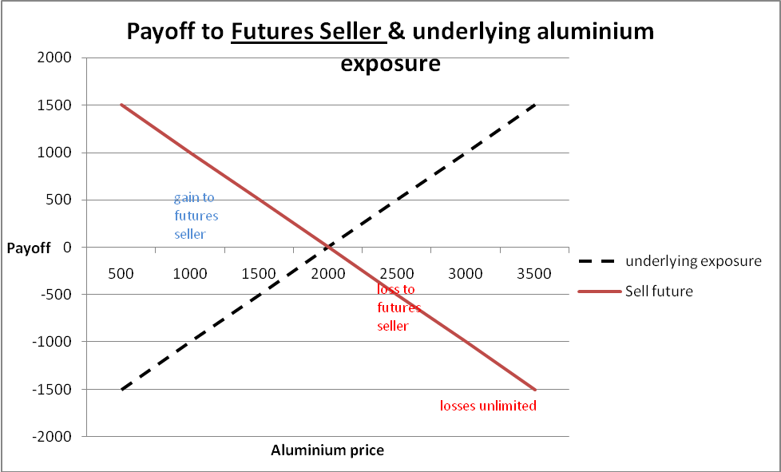

Table of prices;
Aluminium Futures Seller |  |  | aluminium price = | 2000
Commodity producer |  | aluminium spot | underlying
eg. Aluminium producer |  | price | exposure | Sell future
 |  | 500 | -1500 | 1500
 |  | 1000 | -1000 | 1000
 |  | 1500 | -500 | 500
 |  | 2000 | 0 | 0
 |  | 2500 | 500 | -500
 |  | 3000 | 1000 | -1000
 |  | 3500 | 1500 | -1500

In each of these situations, the car manufacture and the aluminium producer have bought and sold futures contracts. They have hedged their position, this has had the effect of locking them into a fixed price. They have eliminated price risk from that part of their operation. But what happens to the car manufacturer if they had bought the future and the price had gone down? They would be locked in to the $2000 price, but they might regret the decision, especially if the price had fallen to $1500. And even more so if their rivals had not hedged.
There is a way for the car manufacturer to protect themselves against rising aluminium prices, but retaining the ability to benefit from falling aluminium prices. They could buy an option.

Options
Options give the holder the right but not the obligation to perform the contract, ie, they can close the contract or they can let it lapse. With the forwards and futures you had a legal obligation to complete the contract. Call options give you the right to buy the underlying at the exercise price, and put options give you the right to sell the underlying at the exercise price.
With the car manufacturer, if they bought a call option it would protect them as the underlying aluminium price rose. They would make a gain on the call option and that would offset the higher price of the aluminium in the cash market. If the price of aluminium fell, the car company could let the option lapse and take advantage of the lower aluminium prices in the cash market and buy at the cheaper price.
This seams a lot better than the futures contract. You are not locked into the fixed price, you are protected against the adverse move, but you can take advantage of a favourable move in your direction. The futures contract is effectively free, the options contract is not free. The options contract offers something very valuable, the ability to participate in a favourable move in the underlying asset. You have to pay for that benefit. This is the price of the option. The option takes away the loss area you would experience in the futures contract. All you can lose in the options contract is what you pay for the option.
What would happen if the car manufacturer bought a call option on aluminium?

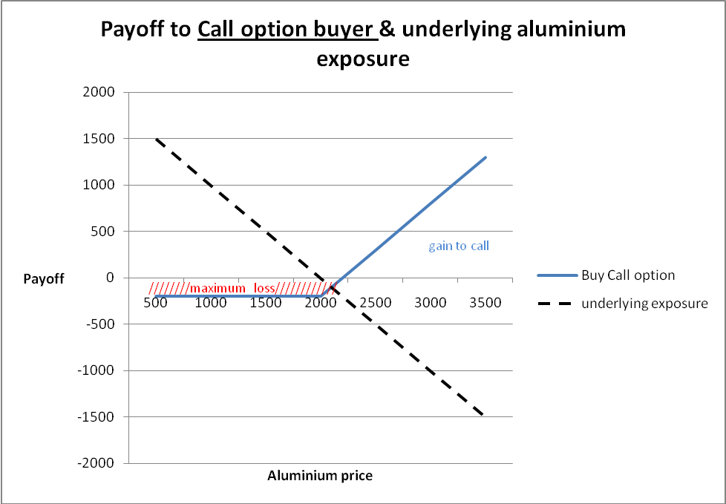

Table of prices; for Car manufacturer
3 month call option; exercise price of $2000 and call option price = $200
 | aluminium price = | 2000
aluminium spot | underlying
price | exposure | Buy Call option
500 | 1500 | -200
1000 | 1000 | -200
1500 | 500 | -200
2000 | 0 | -200
2500 | -500 | 300
3000 | -1000 | 800
3500 | -1500 | 1300

Aluminium producer
If you were the aluminium producer and wanted a similar arrangement; ie, you would be protected if the price of aluminium fell, but could take advantage if aluminium prices rose. They would buy a put option. The payoff profile is shown below. If aluminium prices fell, the producer would benefit from the higher put prices. They would receive a lower price for the aluminium in the market, but that would be offset by the gains made on the put option. With the put, because the producer has the right to participate in the upside if prices rise, they must pay a premium for that right; the option price. The put option is basically an insurance contract. If the price falls you use your insurance contract, if the price rises, you let it lapse. This is just like your house insurance, if your house burns down (price of your house has fallen) you use your insurance contract, if nothing happens you let the insurance contract expire and take out a new one. You have to pay for this. This is the idea behind put options, you are buying protection.

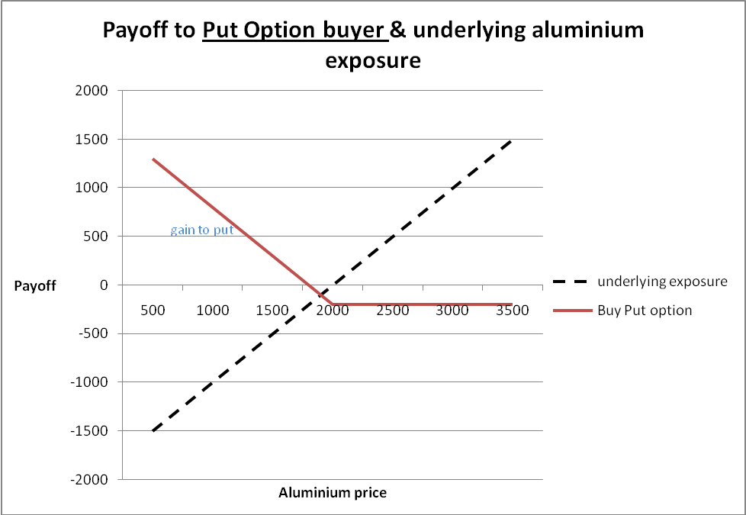
Swaps
Swaps are terminal instruments; they need to be closed out (terminated). The main types of swap are interest rate swaps and foreign currency swaps. A swap is an over the counter contract, ie, a purchaser of the interest rate swap might be a business seeking longer term protection over interest rates and the seller is likely to be a bank.
A forward interest rate contract is a short term instrument. If companies wanted longer protection against interest rate risk, they would have to continually roll over (renew) the forward contracts. The interest rate swap is effectively a package of sequentially dated forward contracts for an agreed period of time. This time period might be 5 years or 10 years, whereas the single forward contract might just be six months in the future. So, one of the benefits of the swap is that it gives the company entering the transaction certainty over a longer period of time, and they don’t need to negotiate a new forward contract every six months.
What exactly happens when a company enters a swap contract? The company and the bank agree a notional sum of money, which may match a borrowing requirement from the company. The original company borrowing may be at a floating rate for seven years (floating rate debt may be lower than the fixed rate borrowing offered to the company). The company may be able to enter into a swap agreement whereby they swap their floating interest rate cash payments for fixed payments. The agreement might state that the company has to pay the fixed rate and the bank will pay floating, LIBOR -0.5% (LIBOR is the London Inter-Bank Offer Rate, an important interest rate that banks lend and borrow from each other, which changes daily). After six months, the bank will pay interest of LIBOR -0.5% to the company and the company will pay the bank the fixed rate. The actual amounts are not paid, only the net difference between the fixed and the floating rates. So, sometimes the bank will pay the company some money (if interest rates rise) and sometimes the company will pay the bank (if interest rates fall). This means the company has removed its exposure to fluctuating interest rates and it will be better off than if it had simply borrowed at a fixed rate originally – this is because they would be paying a higher rate based on their standing and reputation in the market, what the swap does is it allows them to lower that effective borrowing rate by entering into the swap arrangement with the bank or other financial institution.
Interest rate swaps are just the exchanging of one set of cash flows for another.
This will carry on through the life of the swap. While this is going on the company will be paying the interest on its actual borrowing. But if interest rates have fallen over the period, the company will be receiving regular payments from the bank on the other side of the swap. The effect of this is to reduce the borrowing cost for the borrower (this can work the other way and increase costs to the borrower).
The interest rate swaps market is vast, in June 2011, the notional value of outstanding contracts was $553.88 trillion.
They are used both for hedging and speculating. In the swap only the interest rates are swapped, no capital is swapped. Interest rate swaps are one of the most popular hedging tools used by company treasurers.
Option pricing variables
The two option pricing models are the binomial and the Black Scholes (B-S). With the Black Scholes model the pricing variables are; stock price, exercise price, interest rate, time and volatility. Volatility is the most sensitive variable.
All the variables are observable except volatiltiy. You can see the stock price, the exercise price, interest rate, time, and you can see the option price. Given all of these you can imply the volatility from all the other information, the equation would be re-written to solve for the volatility. The traders have the equation programmed into their screens so that the volatility figure is instantly generated.
The basic pricing for a call option is S0 – X, where S0 is the stock price and X is the exercise price. This equation will give you the exercise value of the option and it would give you the value of the option at expiry. But before expiry the option will always have time value. The time value is a function of the time to expiry and the volatility of the underlying stock. The more volatile the stock the more expensive the option, because the more chance it has of rising in value.
So for an option with time to expiry the equation would be Call = S0 + time value – X. The Black Scholes equation captures this value.

Binomial Option
The B-S equation is basically a speeded up version of the binomial. The binomial is a one period model (it can be extended out from one period to multiple periods, and the B-S model is a continuous time model). With the pricing you have two elements to work out; a proportion of the share to buy (equation Y) and an amount of borrowing (equation Z). The equations are given in the exam, but you need to work out the u, d, Cu and Cd values. If the option is for less than a year or more than a year you have to adjust the (1 + rf) in the Z equation accordingly.

Equity in a geared company being like a call option
Shareholders are the ultimate risk takers in a company. They are the residual owners. They get what’s left after paying off the debt holders. In option terms the debt of a company is the exercise price and the value of the assets is the stock price in the model. If the exercise price is greater than the stock price, it means the option is underwater, or out of the money. It means that there is not enough assets to cover the debt. If that situation persisted, then the company would pass to the creditors and the shareholders would be wiped out. But remember with a call option, the buyer cannot lose any more than they have paid for the option. So if the company fails with huge debts, the shareholders only lose the share price, they are not pursued for the outstanding debts.
If the value of the assets is greater than the exercise price, then there is value for the shareholders (S0 – X). If the company is in trouble and X>S0, th e equity will be ‘out-of-the-money’ and if the maturity of the debt is imminent, the equity will have very little value. What often happens in these situations is that there are protracted negotiations with the creditors and sometimes an agreement is reached to extend the maturity of the debt. This is like extending the time value of the option, extending the time value increases the value of the option, so the share price rises – they have more time to try and remedy the situation. Often the interest rate charged on the debt will increase with the restructuring. With a call option, increasing the interest rate increases the value of the call, because the present value of the debt has been reduced. In the company situation, with interest rates rising, the present value of the debt falls, so the value of the equity in the company will rise (assuming the value of debt + equity remains the same, ie, the enterprise value stays the same, with debt value falling, equity value rises).
If the company invests in a riskier project this means the volatility will increase. Normally if something becomes more risky, it would lose value (discounting with a higher interest rate), but with the call option, what you are exposed to is the upside only (remember the payoff diagram, your losses are limited to the option price). So, with the riskier project, if it pays off the shareholders will benefit (after the debt holders have been paid off). If it fails, they lose the option price (share price) and the debt holders will suffer a loss.

Real options
What we have looked at so far are financial options, they can be bought and sold in a financial marketplace. Real options are different. They are options that companies can have that might be activated at some point in the future. It could be an option to expand, an option to delay an investment, an option to abandon.
Taking the option to expand as an example, a company might have an existing project, which has a negative NPV. It might be a strategically important, so the company are looking for some way of justifying the investment. This is where real options comes in. By doing the first project, this may give the company an entry into a second project at some time further in the future. A prerequisite of the second project is that the company enters into the first project. It might be that doing the first project might allow the company to make further advances, to develop a new technology, a new drug, etc. The second project is too uncertain t ovalue in conventional NPV terms, so the option mehtodology is used.
With a financial option, all the variables are observable except the volatility, which can be inferred from the option price. With the real option, the variables are much more uncertain. The exercise price will be the investment required at some point in the future – how much will that be? Who knows? It might be something that escalates rapidly. The stock price is the present value of the follow on investment’s cash flows at the point of investment. This requires you to estimate the possible size of the market for a product that doesn’t exist yet at some point in the future. This has to be discounted to a present value at some point in the future. What will the discount rate be? The time to expiry is the time until the company no longer has an exclusive option, ie, other companies would be able to enter this market.
Where an option gets its value from is the volatility and this is the same for the real option. The value of the real option will be added to the NPV of the first project (which is negative) to give an overall NPV, which the company would like to be positive. The higher the volatility of the future project, the more valuable the option.
Of course, with the real option, it is only an option. When the time comes to invest in the second project, if the outlook is unattractive you can let the option lapse.

Apple Options quote
How to read an options price quote
The following quote is from the Wall Street Journal MarketWatch page, http://www.marketwatch.com/investing/stock/aapl/options
It is a snapshot of the option prices at the close of business on 1st Dec, 2009. If you go back to the page over the next few days you will see how the option prices change with the changing share price.
The central column shows the Exercise Price (Strike Price). Either side is the call and put price data. The call price is highlighted (‘Last’). This shows the last trade for that exercise price series. (Some of the exercise price series will not trade frequently, so the S0 – X will not always follow, because the share price will have changed since the last time that particular option series traded.)
You can see that for Apple (and any option) there are a large number of different exercise prices that you can buy options at. The row with the white gap shows the share price, so the 195 series is very close to the money. Every series above the share price in the table is ‘in-the-money’ and every series below the share price in the table is ‘out-of-the-money’. For example, the Dec 200 call option is priced at $4.10. If Apple stays below $200 for the rest of December, all that money ($4.10) will be lost. If you bought 1 options contract today on the Apple $200 call option, you are buying the right to buy 100 Apple shares at $200 each up until the expiry of the contract (the close of the third Friday in the month, so 18th Dec). One contract would cost you $415 (to the right of the quote is the buy/sell price spread, for this option it is 4.15-4.05) plus commission (Don’t think about buying it, most ordinary investors lose their money in the options market).
In the table vol means volume of trades that day, and Open int means how many contracts are open, ie, there hasn’t been a closing trade yet.
The information is repeated for puts on the other side of the table. At the bottom of the table you can see other expiry dates; Jan ’10, Apr ’10, out to Jan ’12. So you can buy options on Apple with an expiry date more than 2 years away.

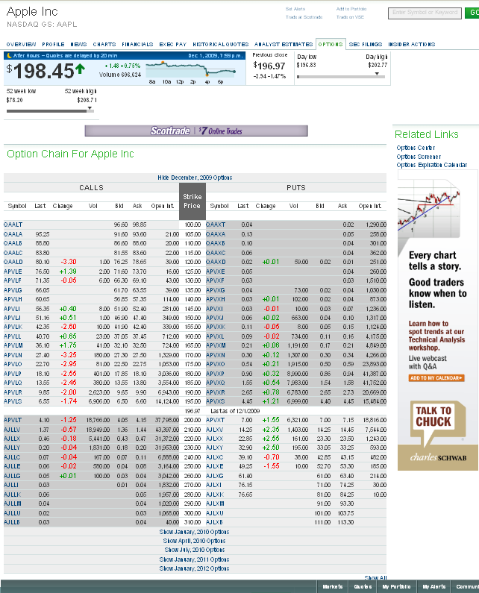
Exercise
Price

Call
Price

